EXPLORE THE WORLD WITH SHEAFE’S FLAT BLUEBIRD
Due: Friday, March 2, 2012

STUDENT NAME: ___________________________________________________ ROOM _____________

Hello everyone! Glad you are still in ASIA with the Flat Bluebird! This week we leave India and travel over the Arabian Sea, northwest to the area of Asia known as the Middle East. It is the part of Asia that is closest to Europe and Africa. As a matter of fact, it is the only place where 3 continents meet!
On the map below, find the countries of Saudi Arabia and Israel. Color Saudi Arabia brown and Israel green. Israel is northwest of Saudi Arabia, along the Mediterranean Sea. Color the Dromedary camel brown and the Israeli sheep white!
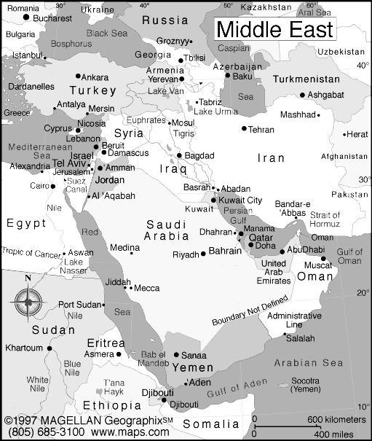
Dromedary camel 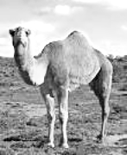 Israeli sheep

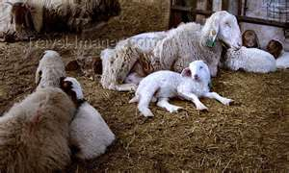

Most of the Middle East is semi-desert or desert. There is agriculture – raising crops and animals. They can use irrigation – piping water in from other areas to water vegetables and keep animals.

Let’s compare and contrast Saudi Arabia and Israel. Saudi Arabia is on the Red Sea. A king governs this country. In Saudi Arabia, they speak Arabic. Because the climate is warm, they grow coffee, olives, dates, grapes, citrus fruits and grains. Oil is under the deserts of Saudi Arabia. Half of the world’s oil comes from Saudi Arabia – oil to heat homes and run our cars! Dromedary (one-hump) camels roam the desert.

Israel is on the Mediterranean Sea. It is a farming country like Saudi Arabia. Irrigation is used in the Negev Desert. In Israel, they grow vegetables, fruits and coffee. Animals such as sheep graze on the hills. In Israel, the leaders are elected, so there is not a king. Arabic and Hebrew are the languages that are spoken in Israel.

Fill in the double-bubble map to tell the similarities and differences of these two countries.

Saudi Arabia
Israel

